**Assignment -2**

Python Programming

|  |  |
| --- | --- |
| Assignment Date | 24 September 2022 |
| Student Name | PARAMESHWARAN VK |
| Student Roll Number | 421319104021 |
| Maximum Marks | 2 Marks |

**Question-1:**

1)Consider a list (list = []). You can perform the following commands:

insert i e: Insert integer at position .

print: Print the list.

remove e: Delete the first occurrence of integer .

append e: Insert integer at the end of the list.

sort: Sort the list.

pop: Pop the last element from the list.

reverse: Reverse the list.

Initialize your list and read in the value of followed by lines of commands where each command will be of the types listed above.

Iterate through each command in order and perform the corresponding operation on your list.

**Program:**

**List.py**

list = [1, 12, 44, 7, 9]

# *Insert integer  at position*

print("Before insert the integer", list)

list.insert(2, 2)

print("Insert integer  at position", list)

print('Delete the first occurrence of integer')

list.remove(1)

print(list)

print("Insert integer  at the end of the list")

list.append(11)

print(list)

print("Sort the list")

list.sort()

print(list)

print("Pop the last element from the list")

list.pop(3)

print(list)

print('Reverse the list')

list.reverse()

print(list)

**Output Screen:**

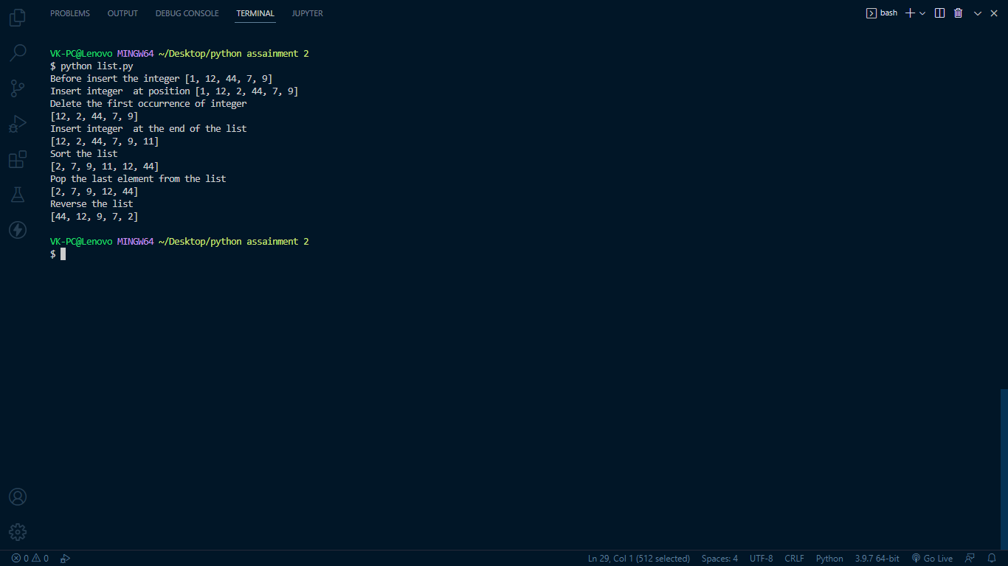

**Question-2:**

**1 .** **Write a Calculator program in Python?**

**Claculator.py**

**# This function adds two numbers**

**def add(x, y):**

**return x + y**

**# This function subtracts two numbers**

**def subtract(x, y):**

**return x - y**

**# This function multiplies two numbers**

**def multiply(x, y):**

**return x * y**

**# This function divides two numbers**

**def divide(x, y):**

**return x / y**

**print("Select operation.")**

**print("1.Add")**

**print("2.Subtract")**

**print("3.Multiply")**

**print("4.Divide")**

**while True:**

**# take input from the user**

**choice = input("Enter choice(1/2/3/4): ")**

**# check if choice is one of the four options**

**if choice in ('1', '2', '3', '4'):**

**num1 = float(input("Enter first number: "))**

**num2 = float(input("Enter second number: "))**

**if choice == '1':**

**print(num1, "+", num2, "=", add(num1, num2))**

**elif choice == '2':**

**print(num1, "-", num2, "=", subtract(num1, num2))**

**elif choice == '3':**

**print(num1, "*", num2, "=", multiply(num1, num2))**

**elif choice == '4':**

**print(num1, "/", num2, "=", divide(num1, num2))**

**# check if user wants another calculation**

**# break the while loop if answer is no**

**next_calculation = input("Let's do next calculation? (yes/no): ")**

**if next_calculation == "no":**

**break**

**else:**

**print("Invalid Input")**

**OutPut Screen:**

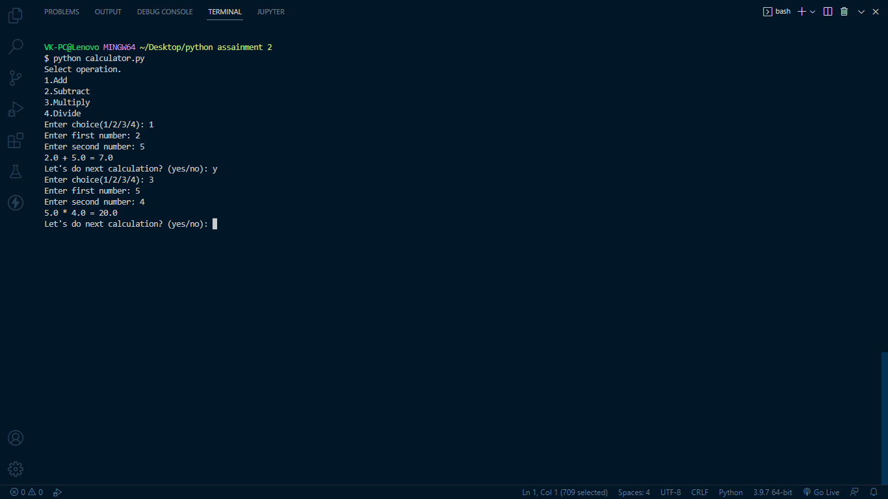

**2.** **Write a program to concatenate, reverse and slice a string?**

**String.py**

var1 = "I Love "

var2 = "Python"

print(var1)

print(var2)

var3 = var1 + var2

print("Sting  concatenate :", var3)

var4 = var3[::-1]

print("String  reverse : ", var4)

print("slice a string :", var3[2:7])

**outputScreen:**

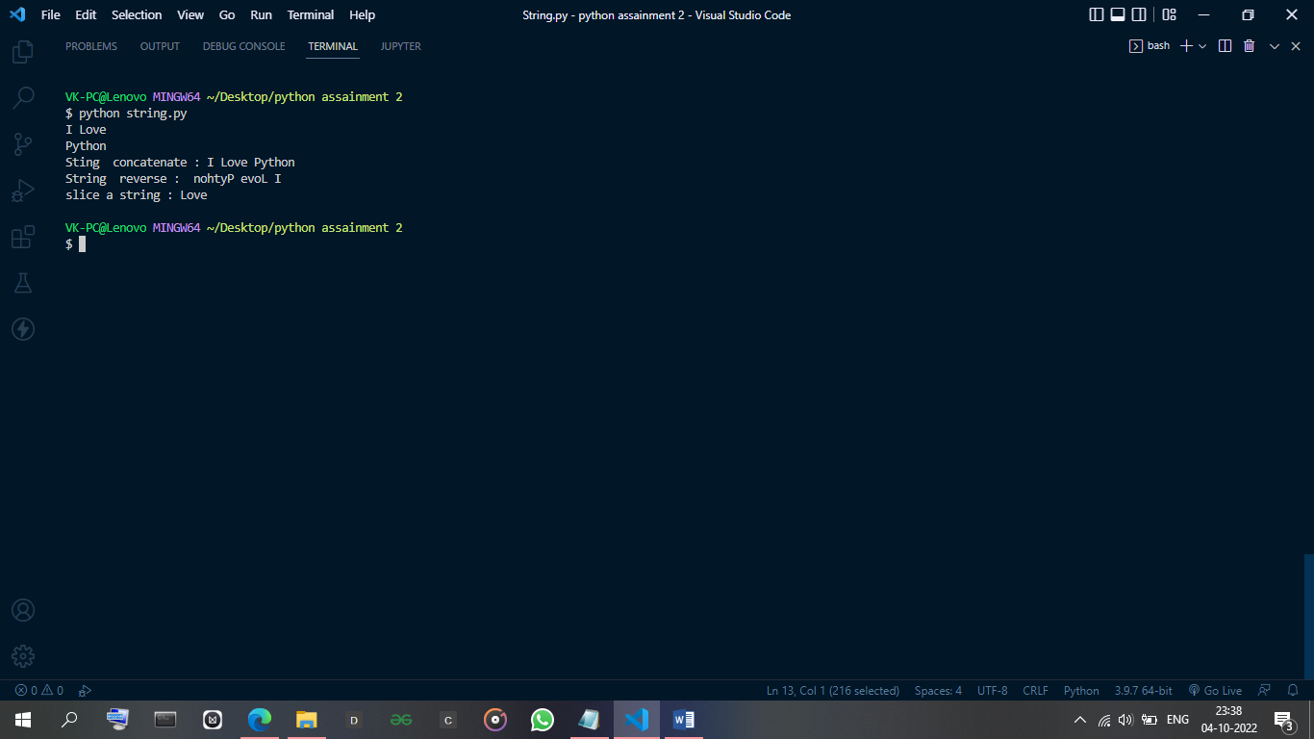

**3.** **Why is Python a popular programming language?**

it has simplified syntax and not complicated, its ease of learning and usage, python codes can be easily written and executed much faster than other programming languages.

**4.** **What are the other Frameworks that can be used with python?**

* Django.
* Flask

**5.** **Full form of WSGI?**

Web Server Gateway Interface